Geometry: Unit 4, Lesson 8
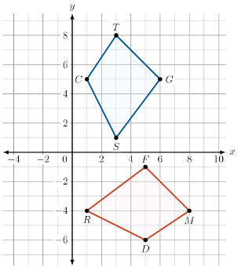
- Quadrilateral $DRFM$ and quadrilateral $CSGT$ are shown. To transform $DRFM$ into $CSGT$, first you must perform a reflection over the $y=x$ line. What is this reflection represented as an algebraic description?

$$(x, y)→(y, x)$$

- If there is a sequence of rigid motion transformations that maps one figure onto another, what does that prove?

The figures are congruent, corresponding angles are congruent, and corresponding sides are congruent
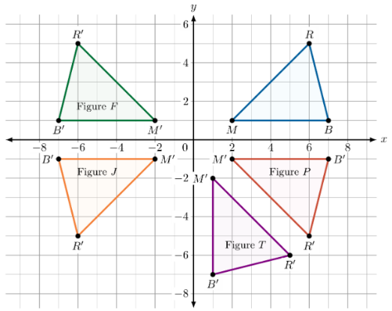
- Triangle $BMR$ and its transformations are shown on the coordinate grid. What figure is the result of a reflection over the $x$-axis of triangle $BMR$?

Figure P

